*<Pressured Alarm System>*

Product Design Specification

Version *<1.0>*

*<25/08/2017>*

TABLE OF CONTENTS

**Introduction** **3**

Purpose of The Product Design Specification Document 3

**General Overview and Design Guidelines/Approach** **3**

**Architecture Design** **3**

Logical View 4

Hardware Architecture 4

Security Architecture 4

**System Design** **5**

Use-Cases 5

Application Program Interfaces 6

User Experience / User Interface Design 6

Performance 6

**Product Design Specification Approval** **7**

# Introduction

## Purpose of The Product Design Specification Document

The Product Design Specification document documents and tracks the necessary information required to effectively define architecture and system design in order to give the development team guidance on architecture of the system to be developed. The Product Design Specification document is created during the Planning Phase of the project. Its intended audience is the project manager, project team, and development team. Some portions of this document such as the user interface (UI) may on occasion be shared with the client/user, and other stakeholder whose input/approval into the UI is needed.

# General Overview and Design Guidelines/Approach

This section describes the principles and strategies to be used as guidelines when designing and implementing the system.

# Architecture Design

In this modern day, where technology is affecting the world, even in the automotive industry. Every modern cars were equipped with technology such as Cruise Control, Engine Control Unit, Parking sensors but with the help of this technology, there is still an increase of automotive theft happening in everyday.

In an diagram below, show the comparison of car theft statistics with last year.

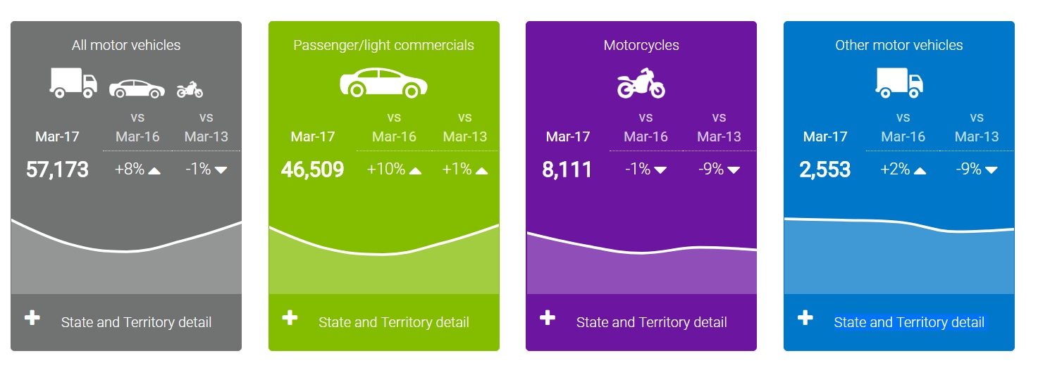

This year, there is a 8% increase of motor vehicles theft compared to last year March 2016 in Australia.

<https://carsafe.com.au/quick>

## Logical View

Majority of the modern motor vehicles were equipped with front and rear dash cam, alarm system, reverse parking system and immobilizer system but people still manage to disarm those security system and get away with the motor vehicle.

The design of this system required a spring loaded sensor which will triggered only when a certain pressure is loaded on the sensor. The minimum load to trigger the system is 30kg.   
There will be a relay which will connect to the sensor and to our motor vehicle’s immobilizer or the alarm system so when the immobilizer is switch on, the sensor will go live. In order to disengage the sensor is to put the key into the ignition. The system have additional wiring which is made specially for cars that is connected to their existing car alarm system. Whenever the alarm system is disengage, the sensor will automatically disengage. The system is built in such a way to prevent people from stealing the motor vehicle while the motor vehicle is in parking mode. This system is to prevent thief from entering the motor vehicle and when the alarm goes off, it will attract many people's attention.

This system is a additional security system added to the existing system to prevent motor vehicle theft and it is hard to bypass or disarm the system.

With this system implemented, it will make your motor vehicle more secure.

## Hardware Architecture

The hardware used will be a pressure sensor, 40 amp relay, 12V battery, 18ga wires, a waterproof alarm, soldering iron, solder, shrink tube, water proof cable protector. This system is invented and created by us and there is no such project in the market. The alarm we are looking for will be a loud alarm which is roughly 80 db and it is powered by an existing 12v battery. Users can also use external battery to power the system.

## Security Architecture

The security of this system will be that all cables will be run on the chassis to the car and all the cables will be in black color without any labels so that the thief could not able to find and disarm the system. The alarm and cables used in the system will definitely be waterproof.

# System Design

## Use-Cases

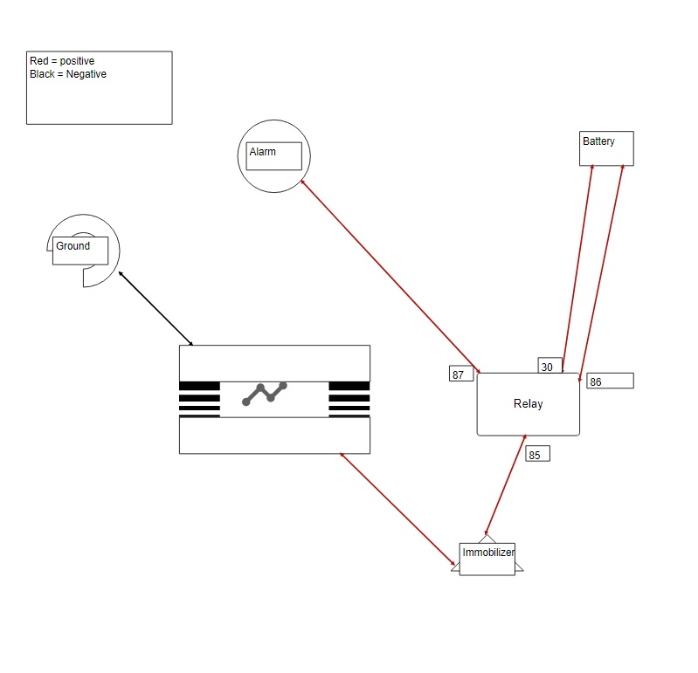

In a relay, there are 5 ports, 85,86,87,30. Port 85 and port 86 form a circuit and port 30 and port 87 form another circuit, it is triggered when port 85 and port 86 form a closed circuit, it will then create a magnetic field and magnetic field will make port 30 and port 87 to form a closed circuit.

In the application of relay in our system, One part of the sensor will be connected to any ground or metal part of the motor vehicle and another part will be connected to the existing immobilizer or the existing car alarm.

The other end of the immobilizer will be connected to the relay port 85.

Port 86 and port 30 are where the power source are supplied to the relay and lastly, port 87 will be connected to the alarm.

When the circuit in the sensor is closed and the immobilizer is on, port 85 and port 86 will form a closed circuit which draw current to the relay. Since port 85 and port 86 is closed circuit, it will have a magnetic field which closed up the circuit in port 30 and 87, hence the alarm will sound off.

## Application Program Interfaces

Our sensor consist of 2 metal plates connected with 2 springs and there is a metal joint on one side of the metal plate. The built in immobilizer act as a switch to control the sensor.

A 18ga wire will be placed on the metal plate where the metal joint were. When it sense a pressure, the spring will retract and the metal joint will be touching the other side of the metal, it will become a closed circuit and current can pass through the metal plate into the immobilizer, if the immobilizer is turned on, it will be sent to the relay switch and it will draw current from the battery and closed the circuit in the relay hence alarm will sound off.

If the immobilizer is at the off position, no current will pass through the relay and the alarm will not be activated. This feature is to ensure that when the owner of the motor vehicle is driving the car.

The immobilizer portion can also be used for car alarm system. The wire which tap into the immobilizer can also tap into the existing car alarm system so when the owner lock the motor vehicle, the sensor will be activate and when the owner unlock the motor vehicle, the sensor will be deactivated. The sensor can be installed in any kind of motor vehicle seats available in the market. Motor vehicle’s owner will have an option to install in all the seats if they wish to.

The pressure sensor will not be visible as the sensors will be in the seat booster cushion. There will be no difference in the seat’s comfortability as the size of the sensor is small.

## User Experience / User Interface Design

Only the owner or the correct key can disarm the pressured alarm system by using the right motor vehicle key and insert it into the ignition of the motor vehicle.

## **Performance**

The pressured alarm system is built to withstand all weather. All the cables and alarm are waterproof and able to withstand the heat coming from the engine. It will not drain the battery of the motor vehicle as it requires a small voltage for the system to operate. The amp we are using is high quality amp which is built to last.

# Product Design Specification Approval

The undersigned acknowledge they have reviewed the *Pressured Alarm System* **Product Design Specification** document and agree with the approach it presents.

|  |  |  |  |
| --- | --- | --- | --- |
| Signature: | Alvinpang | Date: | 25/08/2017 |
| Print Name: | Pang Min Da Alvin |  |  |

|  |  |  |  |
| --- | --- | --- | --- |
| Signature: | Francis | Date: | 25/08/2017 |
| Print Name: | Francis Nacional |  |  |

**Appendix A: References**

The following table summarizes the documents referenced in this document.

|  |  |  |
| --- | --- | --- |
| **Document Name and Version** | **Description** | **Location** |
| *Product Design Specification v1.0* | documents and tracks the information required to effectively in order to give the development team guidance on architecture of the system to be developed. | Pressured Alarm System - Product Design Specification .docx |

**Appendix B: Key Terms**

The following table provides definitions for terms relevant to this document.

|  |  |
| --- | --- |
| **Term** | **Definition** |
| 12V | *12 Volt* |
| *40 amp* | *40 Ampere* |
| *18 ga* | *18 Gauge* |
| 80 db | *80 decibels* |
| Immobilizer | *An* ***immobilizer*** *is an electronic security device fitted to an automobile that prevents the engine from running unless the correct key is present.* |
| Ignition | An **ignition system** generates a spark or heats an electrode to a high temperature to ignite the engine. |